**InsightPredict User Manual**

**A Smart Stock Recommendation System for Personalized Investment Guidance**

**Authors:**

* Bayan Yahia
* Adeeb Ganadry

**1. Introduction**

InsightPredict helps investors optimize their portfolios using advanced analytics and personalized recommendations. This manual will guide you through all essential features of the system.

**2. Getting Started**

**2.1. Logging In**

1. Open the project in visual studio
2. Open up 2 terminials
3. In one of the terminals type npm start
4. Go to the second terminal and type cd backend =and then=> npm start
5. This will open your web browser with the project after a short pause

**3. Main Dashboard**

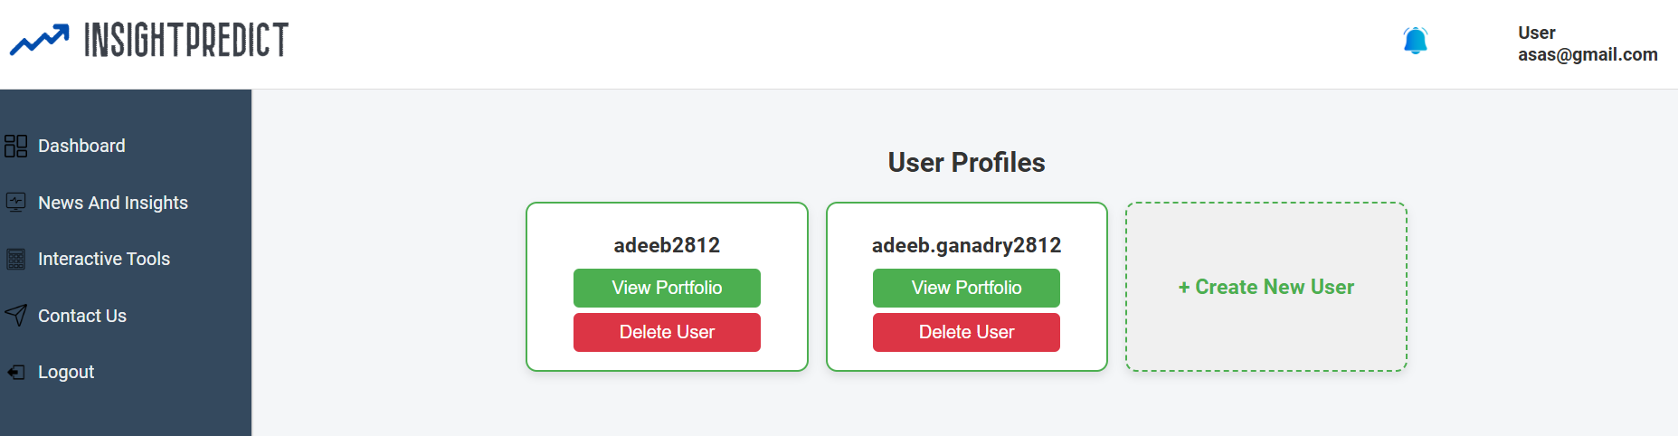

1. When first logging in, you'll be able to see all the active profiles
2. You can enter/delete a certain profile by pressing the corresponding button on that profile name
3. Once logged in, you can access the following options from the left-side menu:
   1. Dashboard: View user profiles, delete profiles, create new profiles
   2. News and Insights: Stay updated with the latest stock market news and trends.
   3. Interactive Tools: Access tools for stock analysis and portfolio management.
   4. Contact Us: Reach out for support or provide feedback.
   5. Logout: Safely exit your account.
4. 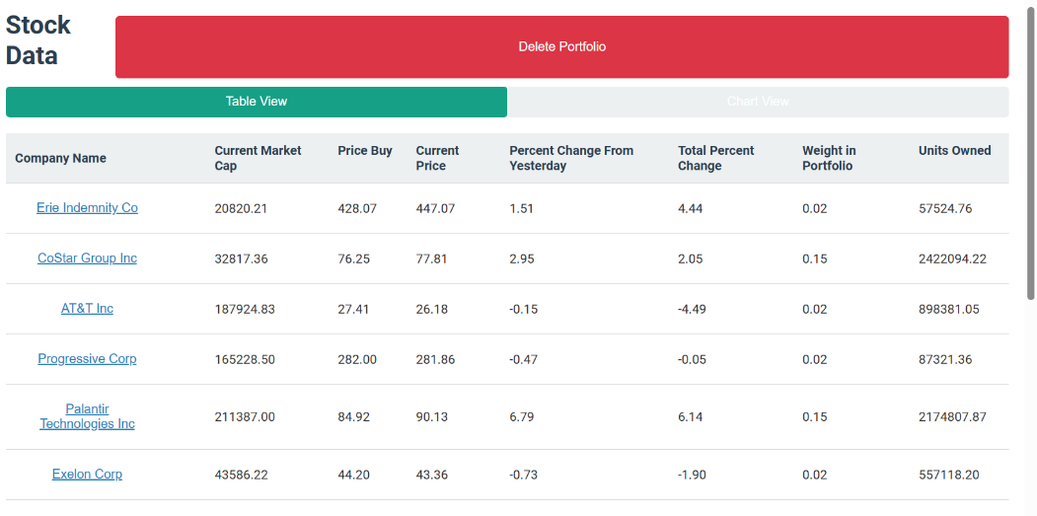**Profile:**

Inside each profile you can find:

* Table view: the individual stocks in your portfolio
* Chart view: the total change of the port

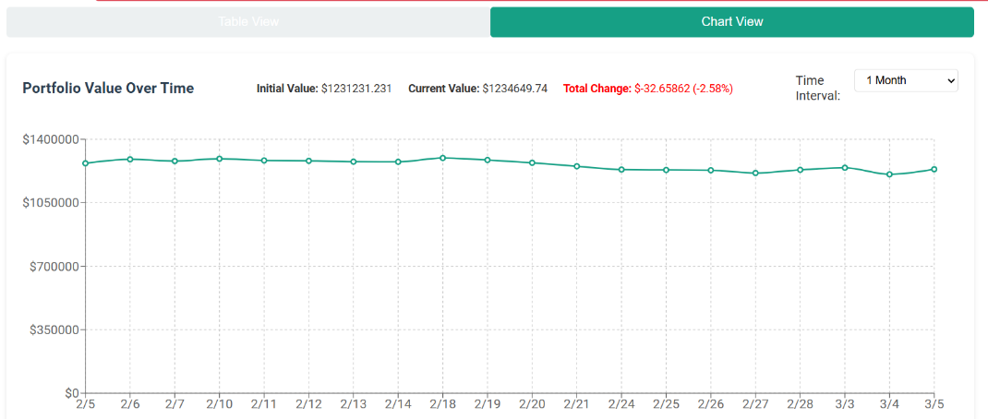

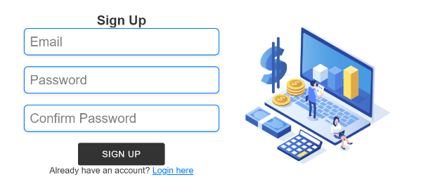**4. Creating a new profile**

when you press on create a new profile you will be asked to enter an email, a password, and confirm the password, then the following steps have to be done:

**4.1. Risk Profile**

1. 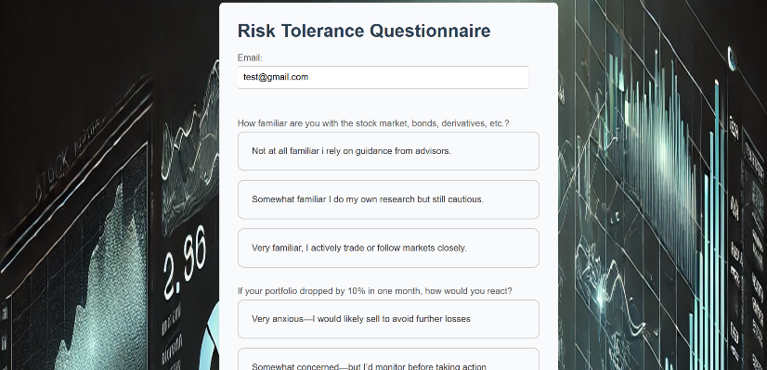Select the clients risk tolerance level by answer the multiple answer questions each with 3 answers for different risk levels:
   * Conservative: Lower risk, moderate returns
   * Moderate: Balanced risk and return
   * Aggressive: Higher risk, potential for higher returns

**4.2. Investment Horizon**

Select your preferred investment timeframe:

* Short-term (less than 1 year)
* Medium-term (1-5 years)
* Long-term (over 5 years)

**4.3. Portfolio Size**

Choose your preferred portfolio size:

* 15 stocks (highly focused)
* 20 stocks (balanced)
* 25 stocks (more diversified)

**5. Interactive tools**

**Stock Calculator:** Allows users to calculate potential earnings based on the stock symbol, number of shares, and initial investment.

**Stock Comparison Tool:** Compares performance trends of selected stocks, helping users make informed decisions.

**Investment Simulator:** Simulates portfolio management by enabling users to buy/sell stocks and visualize portfolio allocation with dynamic charts.



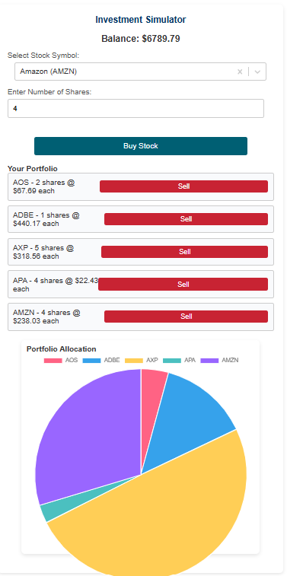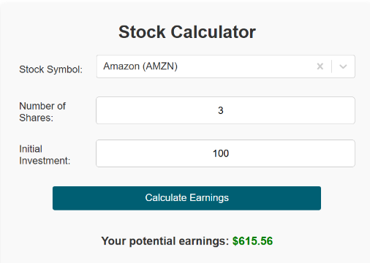

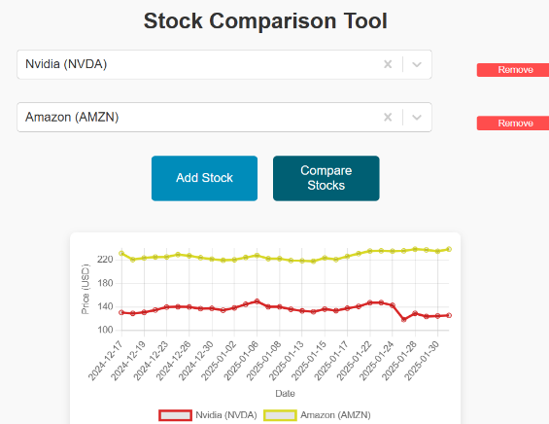

**6. News and Insights:**

Displays the latest stock market updates and news headlines, helping users stay informed about trends and events affecting their investments.

